Supplementary Information

Contents

A. Materials and Methods
A.1 SARS-CoV-2 variants in South Korea by analyzed sequences
A.2 Daily instantaneous Rt calculated via Epiestim
A.3 R0,t by variant
A.4 WHO 2020 criteria
A.5 Derived Risk Indicators
A.6 Weekly practical vaccination rate
A.7 Monthly effects of humidity in South Korea by season

B. Validation
B.1 The sample chains of parameters obtained by MCMC
B.2 Posterior distribution of each parameter

A. Materials and Methods

A.1 SARS-CoV-2 variants in South Korea by analyzed sequences

In this study, we used data from Our World in Data to determine which SARS-CoV-2 variant was most prevalent in South Korea during specific timeframes. The proportions of SARS-CoV-2 variants identified among analyzed sequences between May 2020 and July 2022 are as follows.
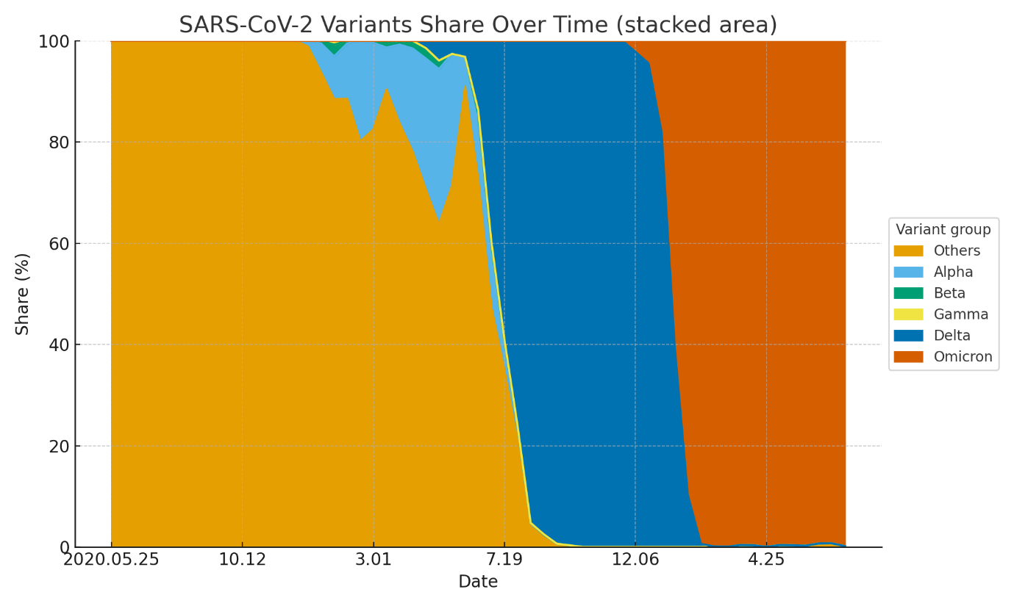
Fig. 1. SARS-CoV-2 variants in South Korea by analyzed sequence from May 2020 to July 2022

The data reveals that the Wuhan strain was dominant throughout 2020. From January to June 2021, while the Wuhan strain remained prevalent, the Alpha variant was also observed, along with sporadic detections of the Beta and Gamma variants.
Beginning in July 2021, the detection rate of the Wuhan strain declined as the Delta variant rapidly gained dominance, accounting for over 90% of all analyzed sequences by August. This trend persisted until December 2021. From January 2022, the Omicron (BA) variant's proportion exceeded 90% and maintained this level through July 2022.
Based on these observations, the target variants for investigating period-specific SI values were determined as follows.
- January 2020 – July 2021: Wuhan Strain
- August 2021 – December 2021: Delta Variant
- January 2022 – Present: Omicron (BA) Variant

A.2 Daily instantaneous Rt calculated via Epiestim

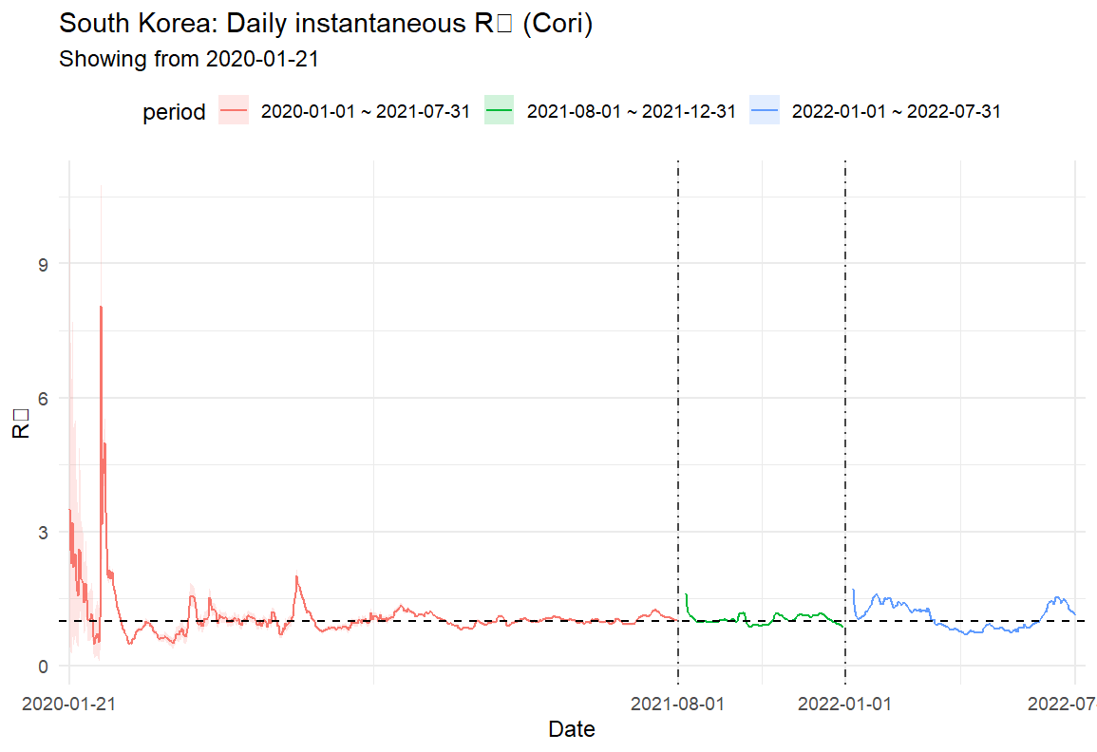
Fig. 2. Daily instantaneous Rt in South Korea via Epiestim, 2020.01 – 2020.07 Different color has been used for each period.

A.3 R0,t by variant

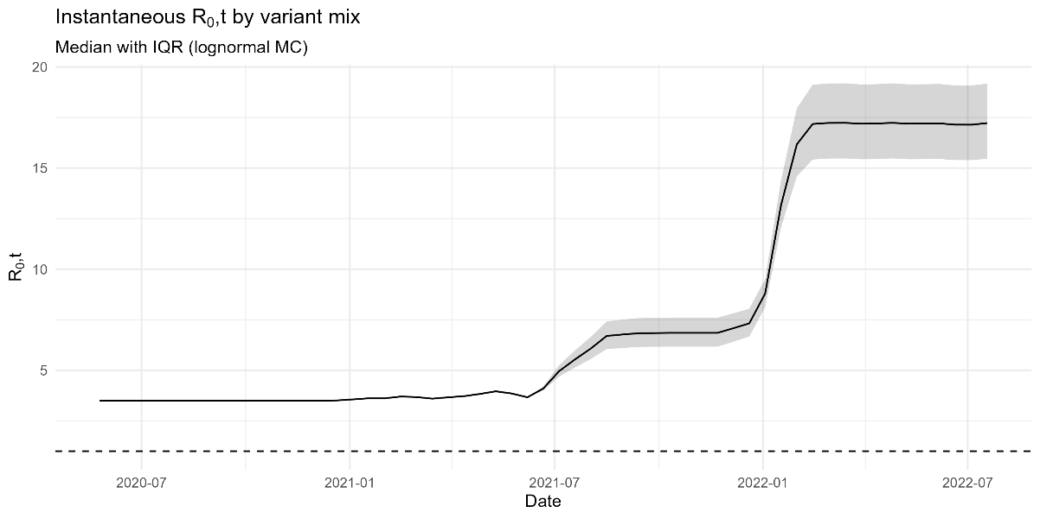
Fig. 3. Instantaneous $R_{0,t}$ of South Korea, 2020.05 – 2022.07

A.4 WHO 2020 criteria
The framework we used in calculating the effects of non-pharmaceutical interventions aligns the six WHO 2020 criteria with the OxCGRT database to provide a robust Risk Index for the South Korean context.
Table. 1. WHO recommendations on PHSM and risk indexes
WHO recommendataion | Data sources | Risk index sub-component
Transmission controlled | No OxCGRT indicators  Daily cases and deaths data from European Centre for Disease Prevention and Control and John Hopkins University CSSE COVID-19 Data Repository | A metric between 0 and 1 based on new cases confirmed each day. This is captured in two dimensions:  1. A measure to account for a localised outbreak  2. An 'endemic factor' that modulates the index according to the total number of new cases
Test / trace / isolate | OxCGRT: H2 (testing policy)  OxCGRT: H3 (contact tracing policy)  Testing data from Our World in Data | A metric between 0 and 1; half based on testing and contact tracing policy, and half based on the number of tests-per-case a country has conducted.  (does not measure isolation)
High vulnerability settings | Not currently measured | Not currently measured
Preventative measures established in workplaces | Not currently measured | Not currently measured
Manage risk of exporting and importing cases | OxCGRT: C8 (international travel restrictions) | A metric between 0 and 1 based on the stringency of the country’s restrictions on travel arrivals.  (does not measure risk of exporting cases)
Communities understanding and behaviour change | OxCGRT: H1 (public information campaigns)  Travel and mobility data from Apple and Google.  Daily cases and deaths  (from European CDC via Our World in Data) | A metric between 0 and 1 based on whether a country has a public information campaign and the level of mobility reduction, weighted for current transmission risk.

Furthermore, according to the 2023 World Health Organization (WHO) report, “Considerations for implementing and adjusting public health and social measures in the context of COVID-19,” Public Health and Social Measures (PHSM) should be implemented and adjusted based on specific situational levels. The recommended categories of PHSM include:
- Individual PHSM (e.g., masking, hand hygiene)
- Mass gatherings and high-risk settings
- Surveillance, including genomic sequencing
- Contact tracing and supported quarantine
- School settings (e.g., ventilation and hygiene protocols)
- Businesses (e.g., cleaning, hand hygiene, and ventilation)
- Domestic movement and travel restrictions
- Healthcare (e.g., home isolation protocols and infrastructure)

A.5 Derived Risk Indicators

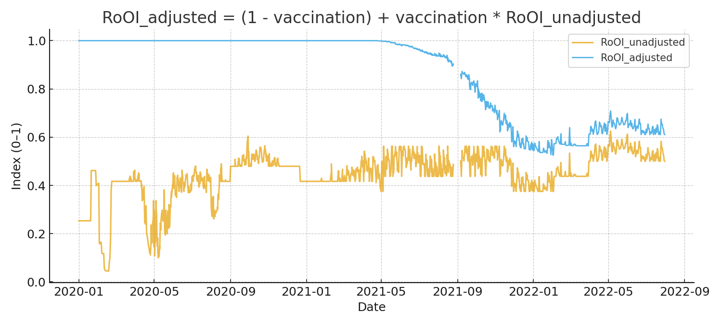
Fig. 4. Adjusted risk of openness index in South Korea, 2020.01 – 2022.07
Before March 2021 when vaccination was initiated, $Ro{OI}_{adjusted}$ is maintained as 1, then starts to move in a similar pattern with $Ro{OI}_{unadjusted}$ from December 2021.

A.6 Weekly practical vaccination rate
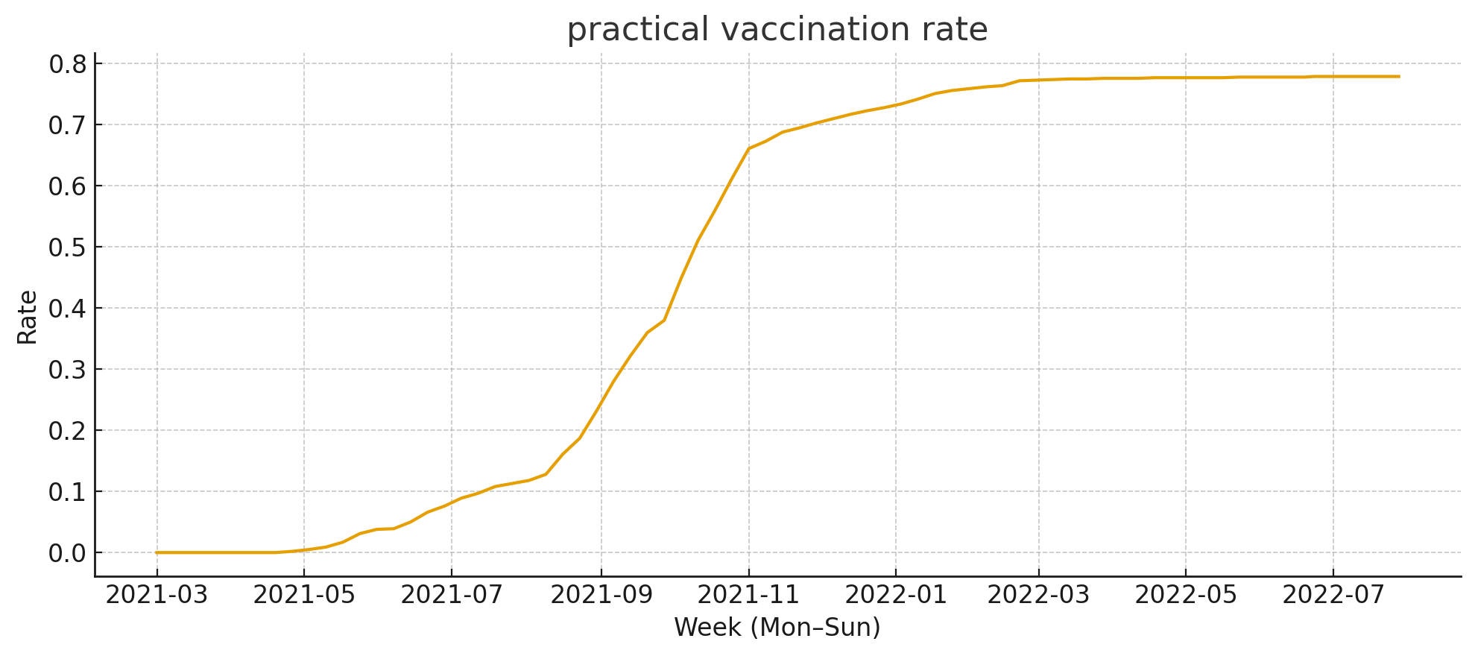
Fig. 5. Practical vaccination rate in South Korea, 2021.03 – 2022.07

A.7 Monthly effects of humidity in South Korea by season

The humidity variable demonstrates distinct seasonality, with its impact varying significantly according to the month and the broader climatic conditions of each season.

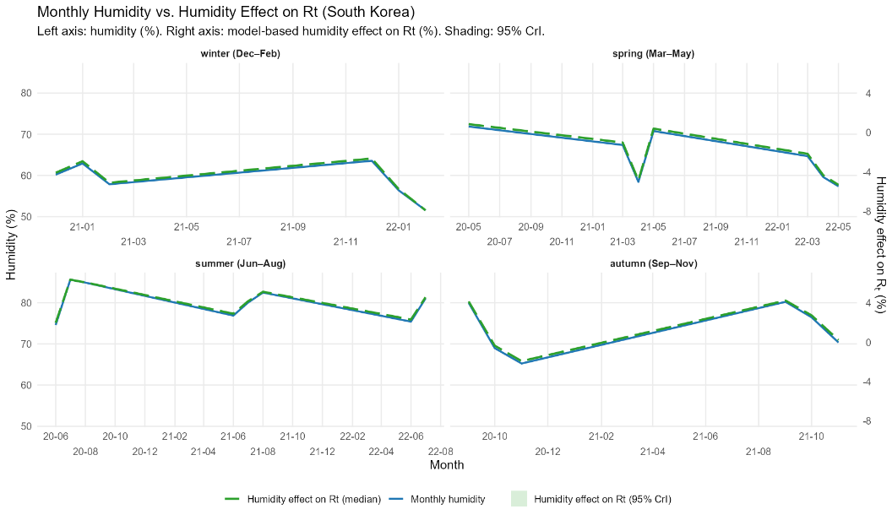
Fig. 6. The monthly effect of humidity in South Korea
Considering the season and humidity as %, the effect of humidity was higher in the summer.

B. Validation

B.1 The sample chains of parameters obtained by MCMC

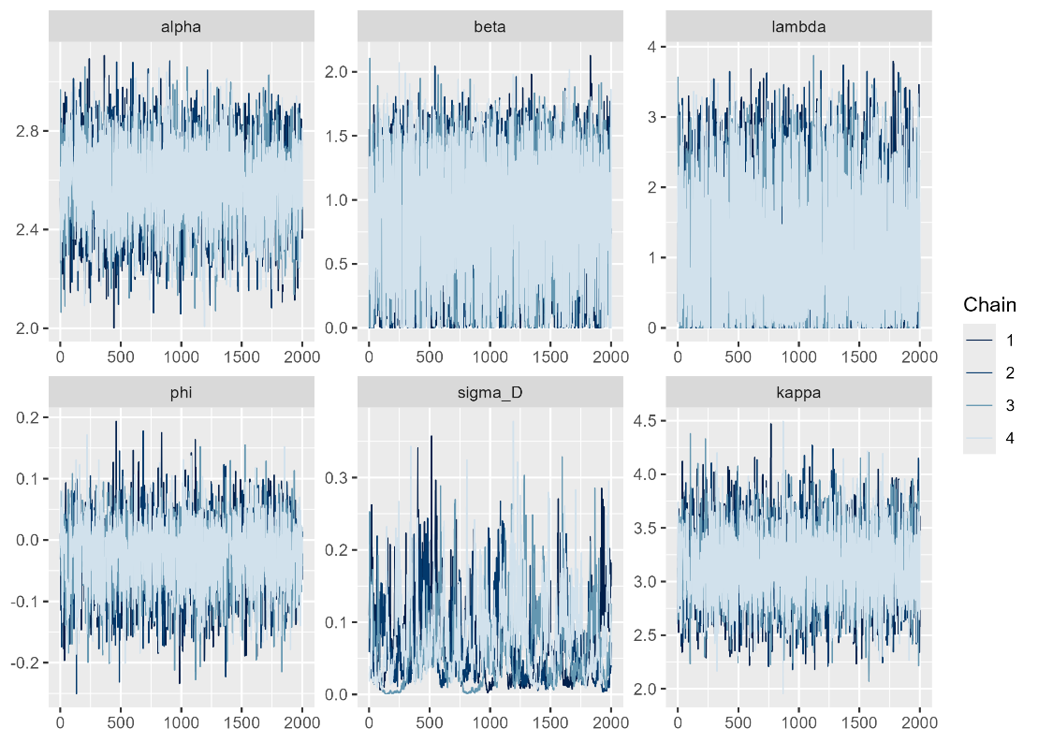
Fig. 7. The sample chains of parameters obtained by MCMC

The figures above illustrate the sample chains for each parameter obtained through the MCMC process. The parameters are defined as follows:
- Alpha) The intercept, representing the baseline value when all covariate effects are zero.
- Beta: The slope, which represents the effect of the covariates; specifically, it denotes the average change in the dependent variable y for every unit increase in the independent variable x.
- Lambda: Represents the effect size or intensity of additional covariates.
- Phi: A parameter denoting the correlation or the error structure within the model.
- sigma_D: Characterizes the dispersion or spread of the data points around the model’s predicted curve.
The density of these sample chains converges toward the posterior distribution, $P(θ)$. To assess the convergence and stability of the model, we utilized the R-hat statistic and the effective sample size $n_{eff}$.

B.2 Posterior distribution of each parameter

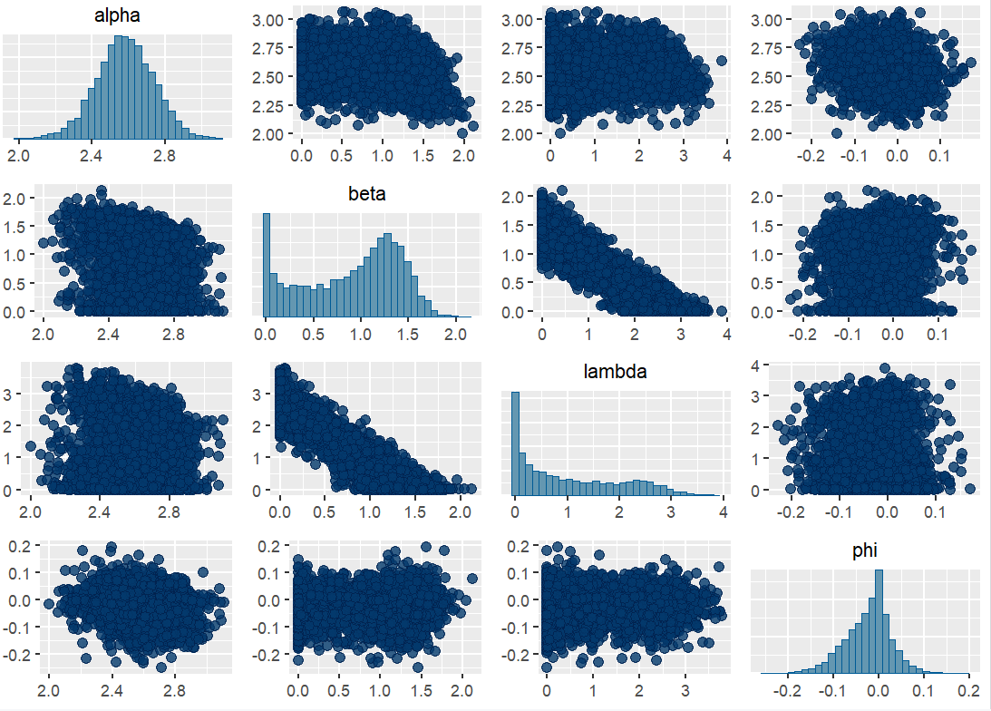
Fig. 8. Posterior distribution of each parameter
The figures above present the univariate posterior distributions of each parameter via histograms, while the scatter plots illustrate the covariance and correlation structure between parameters.
A notable negative correlation was observed between beta and lambda. This suggests a high degree of uncertainty when attempting to decompose and present the estimated effects of NPIs and vaccination independently. Consequently, presenting the combined efficacy of vaccination and NPIs provides a higher level of statistical reliability than presenting them in isolation.

